**GMITProjectWebsite User Guide**

**Website Installation**

1. Navigate to the webpage <https://github.com/AAcquier/GMITProjectWebsite>
2. Download the file G00293624-WebsiteProject.zip
3. Unzip the file G00293624-WebsiteProject.zip
4. Install the folder G00293624-WebsiteProject results of the unzip onto your web server by copying and pasting it in the proper location on your system, for example if using XAMPP or assimilated use the path: ***C:\xampp\htdocs***
5. Open the G00293624-WebsiteProject folder and find the lionss_users.sql file and install it onto your DBMS.
6. Once all the previous steps have been undertaken, open a web browser and access the module_website.html file by using localhost to start the address link. For example, if the G00293624-WebsiteProject folder has been installed as described in step 4, the address to type into the browser address bar should be***:***

***http://localhost/G00293624-WebsiteProject/module_website.html***

Now you should be able to either check out the labs done in the different weeks or to check out the project website by using the links build in the module_website.html webpage.

**Core requirements:**

**PART 1:**

The login and register are displayed on the same page, there is also an option to view the different users. All the above can be accessed using tabs.

The login, register and the view users options are respectively contained in the login.php, register.php and view_users.php. The login.php is associated to a login.html file contained in the includes folder in the G00293624-WebsiteProject folder.

The login.php, register.php and view_users.php use the same header and footer which are contained in the includes folder in the G00293624-WebsiteProject folder, in the same folder is the style.css file which is the stylesheet for those pages as well as the picture logo.jpg used for the logo of the header.

The code used to store the new login information from the register page in the users table of the lionss_users database as well as the login check are to be found in the register.php and login.php files, the mysqli_connect.php file is used to connect those scripts to lionss_users the database.

The password in the login and register are encrypted and decrypted using the SHA1 function into the php files.

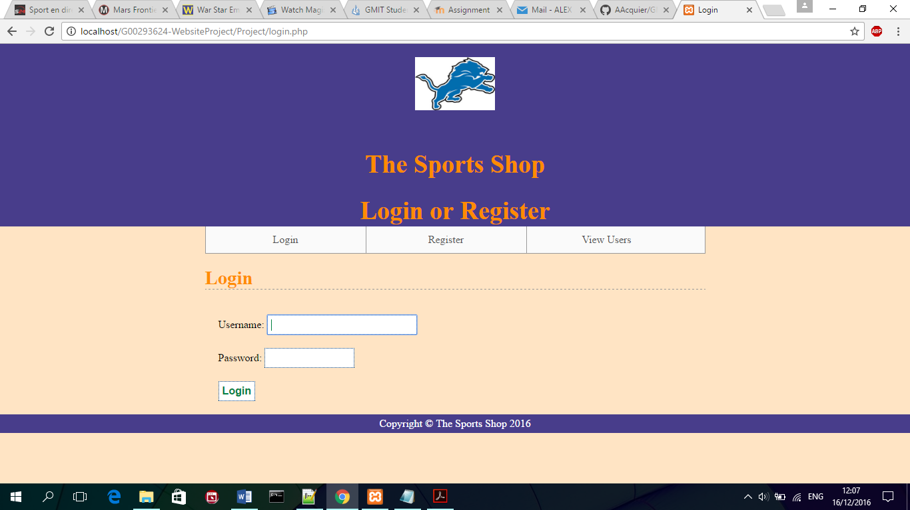

**Login.php page**

**PART 2:**

If the login or registration is successful, the user will be directed to the index.html page which is the presentation page, from there the shoes.html, the trackSuits.html and the kits.html can be accessed using the navigation bar. The redirecting to the index.html can be found in line 36 of login.php and line 30 of register.php. From index.html, all the html pages use the style.css stylesheet contained in the G00293624-WebsiteProject folder.

**PART 3:**

Once on one of the three pages containing the items, select a size and quantity, the price will then be adjusted using the functions in jquery.shop. js file (lines 4 through 193) and click the ***Add to cart*** button to store those values in the storage. The product data will then be stored in the session storage through the jquery.shop. js file (lines 294 to 645) which is contained in the js folder of the G00293624-WebsiteProject folder.

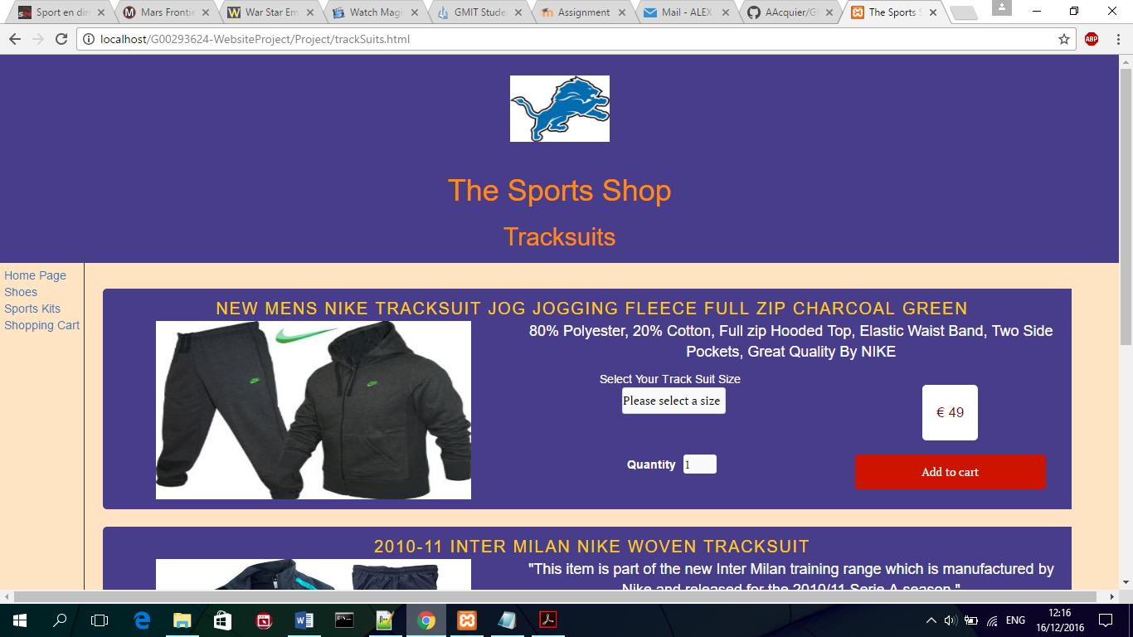

**Example of an item**

**PART 4:**

The content of the cart is then displayed under the form of a table in cart.html using the file nameList.js (lines 2 to 53) which is contained in the js folder of the G00293624-WebsiteProject folder.

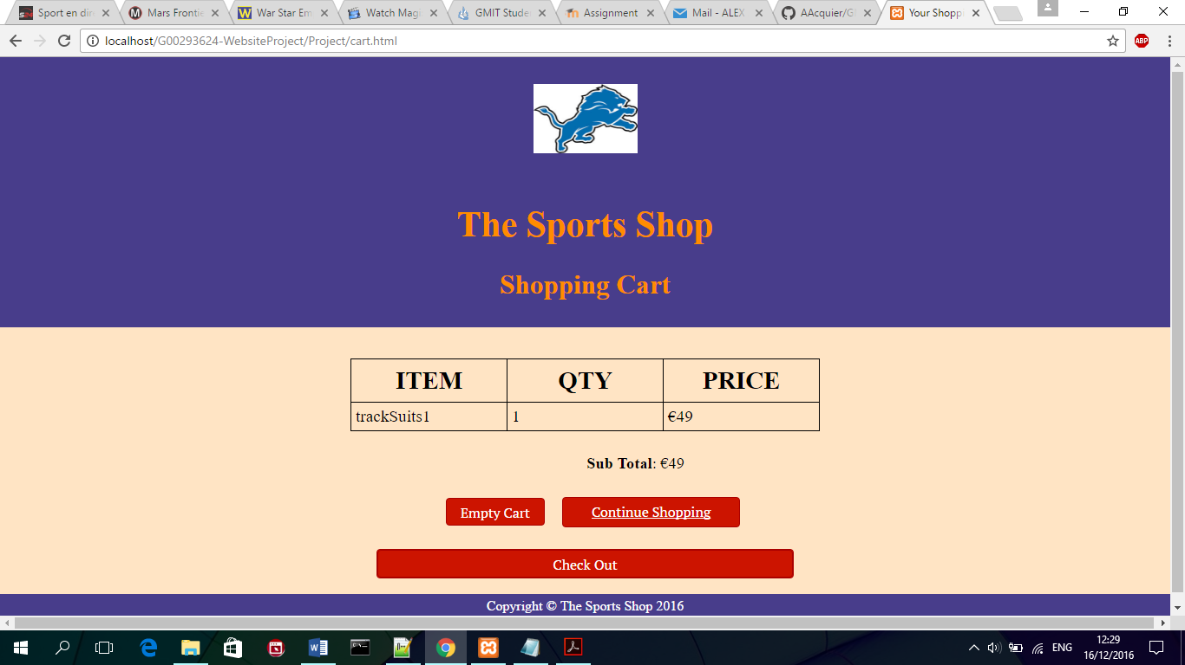

**Shopping cart table**

**PART 5 AND 6:**

An event listener to erase row of the table is present and its code can be found in nameList.js (lines 56 to 75) which is contained in the js folder of the G00293624-WebsiteProject folder.

**PART 7:**

By clicking the ***Check Out*** button, the user is directed to the checkout.html page where he can enter its payment details.

**PART 8:**

The validation payment is handled by the finish function in the jquery.shop. js file (lines 197 to 265) which is contained in the js folder of the G00293624-WebsiteProject folder.

**PART 9:**

Once the credit card number has been validated, the user is directed to the confirmation.php. The code from lines 2 to 45 handle the storing of the data into the orders table of the lionss_users database. Once it is done, it displays the sum debited from the account as well as the order ID.

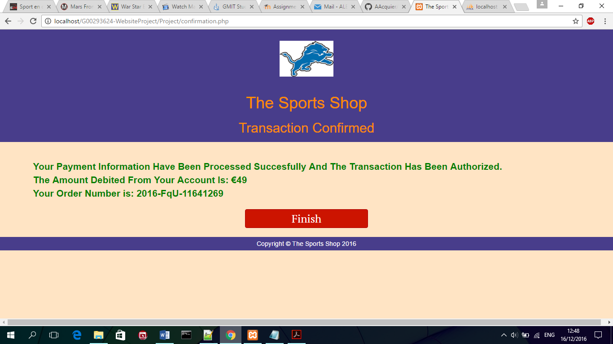

**Confirmation.php after validation of the order.**